|  |
| --- |
| VIETNAM NATIONAL UNIVERSITY, HANOI **INTERNATIONAL SCHOOL**  ***  **PROJECT**  ADVANCED INFORMATION SYSTEMS DEVELOPMENT  Teacher: Nguyen Nhat Hai  Student’s full name:  An Khanh Ha - 16071279  Nguyen Thi Huong Giang - 16071275  Tran Thi Ninh - 16071299  Major: Management Information System  Class: MIS2016A |

Contents

Chapter 1: Introduce the topic 3

1.1. About the topic: 3

1.2. User group: 3

1.3. Operationg enviroment: 4

Chapter 2: Analysis and system design 4

2.1. Use-case diagram 4

2.1.1. Use-case diagram 4

2.1.2. Specification of use-cases 6

2.2. Generalized usecase diagram. 16

2.3. Decomposed usecase diagram 16

2.4. Relational model 26

2.5. Sequence Model 28

Chapter 3: Achievements and development directions 34

3.1. Results interface 34

3.2. Development 37

REFERENCES 37

# Chapter 1: Introduce the topic

## About the topic:

We have chosen the topic of "building a website to manage clothes shop".

This is a website to sell and introduce the store's products to consumers with quality products and reasonable prices.

- The website helps customers to view products and order online without spending time to the store, users can also read the news.

- In addition, when customers have an account to log in to the site, users can manage their personal information, and can comment and rate a product.

- For users who do not have an account, they can sign up and also buy and read news.

- With the desire to promote the company's products and images to consumers, the website also has a separate introduction about the company.

- For customers who want to read news about new promotions, new products or featured products, users can also choose to read and find out.

## User group:

Administrators: this user group has the highest privileges on the system. Can create and manage all other user groups, perform functions such as: Product management, order management, warehouse management, promotion management.

Customers: Including potential customers (those who came for reference but have not yet participated in product purchase) and customers (who participated in buying products). This is considered a key user group of the client interface.

## Operationg enviroment:

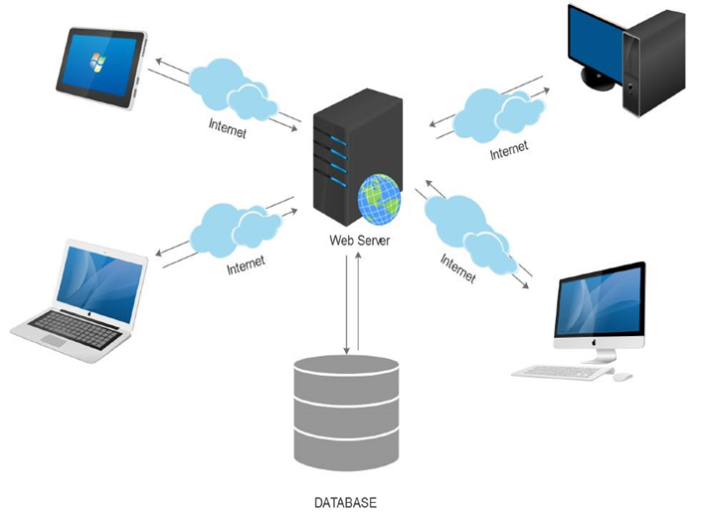

* 1. Technology used:

 - PHP language

- phpMyAdmim data management tool

- XAMPP web server creation program

- MySQL database management system

# Chapter 2: Analysis and system design

## 2.1. Use-case diagram

### 2.1.1. Use-case diagram

Based on the system description, we can identify the main factors:

Customers: factors that directly impact the system, use the system to conduct its transactions with the company through the company's website. Customers factor have the function:

* Watch products
* Search
* Cart management
* Add products to cart
* Payment/ Checkout
* Watch news
* Sign up
* Log in
* Log out

#### The website administrator has the functionality:

* Watch products
* Search product
* Product Management
* Add products
* Delete the product
* Edit product information
* News management
* Add more information about the company
* Edit information
* Delete information about the company
* Website: an external function
* Information of customer transactions.
* Display and enforce customer transaction requirements
* Display information about the product
* Determining the functions used of the website
* Cart management
* Add products to cart
* Remove products from the cart
* Payment/Checkout
* Log in
* Log out

### 2.1.2. Specification of use-cases

##### Usecase login specification

a) Brief description

• Use case name: Log in.

• Purpose: Describes how the system administrator logs on to the system to perform tasks for the website.

•Factor: Admin

b) Event streams

• Key event streams

* The use case starts when an administrator logs on to the system
* The system checks the validity of the information entered by the system administrator. If the information entered is not valid, execute stream A1.
* The system records the login process.
* Branching streams
* A1 Stream: Invalid input.
* The system notifies users that such information is invalid.
* Require users to retype.

c) Pre-condition: None

d) Post-condition: If the login is successful, the system administrator can perform management operations with the system.

##### Use case adds cart to the basket

a. Brief description

• Use case name: Add the item to the basket

• Purpose: Describes how customers add products to their shopping carts

• Factor: Customers

b. Event streams

• Main event stream

* The use case starts when the customer clicks the order button. The system will automatically add that product to the cart.
* Cart display system.
* The display system of products.
* The system requires customers to fill in the number.
* Customers update the product
* The system checks if the goods are in stock. If no more systems implement the A3 stream.

• Branching streams

* A3 Stream: If the stock is no longer in the quantity requested by the customer.
* The system notifies customers that stock is not enough.
* Request customers to add another product.

c. Precondition: No.

d. Post-condition: If the item is in stock, the item is added to the customer's cart.

##### Use case update cart

a. Brief description

• Use case name: Updating the cart in the basket

• Purpose: Describe how customers update products in their shopping cart so that they can buy products exactly as they want

• Factor: Customers

b. Event streams

• Main event stream

* The use case starts when the customer clicks the update button in their cart view tab. The system will automatically update the product in the cart according to the customer's wishes.
* Cart display system
* The display system of products
* Customers edit the selected product information
* The system requires customers to fill in the number
* The system checks if the goods are in stock. If no more systems implement the A3 stream.

• Branching streams

* A3 stream: If the stock is no longer in the quantity requested by the customer
* The system notifies customers that stock is not enough
* Request customers to update another product

c. Precondition: No.

d. Post-condition: If the item is in stock, the item is updated in the customer's cart.

##### Use case payment/checkout

a. Brief description

• Use case name: Payment

• Purpose: Describe how customers pay money to the company.

• Factor : Customers.

b. Event streams

• Main event stream

* Use case starts when the customer selects the Payment function.
* The system requires customers to enter full information including full name, address, email, cafe number ..
* The system checks if the customer's information is valid or not, if not valid, then execute stream A1. If it is valid, the system will continue to check whether or not the product in the shopping cart of the customer is active.
* The system will provide customers with a customer code and save it to the system.
* The system records payment transactions, informing customers in detail of the time of receipt and payment via email address.

• Branching stream

* A1 stream: Invalid cafe number or email address
* The system displays a notification to customers, customers can re-enter information or press the "Exit" button to cancel the transaction.
* A2 Stream: No products in the basket
* The system will display a notice letting customers know that customers can choose or cancel when the use case is over.

c. Postconditions

* If the payment transaction is successful, the system will send notice of the time the customer receives the goods and makes payment
* The transaction will be saved to the system.

##### Use of additional products

a. Brief description

• Use case name: Add the product

• Purpose: Describes how system administrators add products to product lists

• Factor: System administration.

b. Event streams

• Main event stream

* After successfully logging in, the system administrator can perform the functions.
* The use case starts when the system administrator selects the function to add a product.
* The system requires the system administrator to enter the product code, product name, and additional product information.
* Administration of product information input system.
* The system checks if the product code that the system administrator entered is valid or not, and if it is invalid, then execute A1 stream.
* The system displays the system administrator information that has been entered.
* The system administrator press "OK" to make more products. Or click "Cancel" if the system displays information that does not match the information that the administrator has filled out.

• Branching stream

* A1 stream: The product code already exists
* The system displays a notice telling the administrator that the administrator can retype the information or press the "Exit" button to cancel the addition.

c. Precondition: The system administrator has successfully logged into the system.

d. Post-condition: If the announcement is successful, the item will be added to the company's database.

##### Use case product updates

a. Brief description

• Use case name: Edit the product

• Purpose: Describes how the system administrator fixes the product in its product catalogs

• Factor: System administration.

b. Event streams

• Main event stream

* After successfully logging in, the system administrator can perform the functions.
* The use case starts when the system administrator chooses the product repair function.
* The system requires the system administrator to enter the product code, product name, and product information to be corrected.
* Administration of product information input system.
* The system checks if the product code that the system administrator entered is valid or not, and if it is invalid, then execute A1 stream.
* The system displays the system administrator information that has been entered.
* The system administrator press "OK" to perform product repair. Or click "Cancel" if the system displays information that is inconsistent with the information that the administrator has filled out.
* Branching stream
* A1 stream: The product code already exists
* The system displays a notice telling the administrator that the administrator can retype the information or press the "Exit" button to cancel the addition.

c. Precondition: The system administrator has successfully logged into the system.

d. Post-condition: If the announcement is successful, the item will be added to the company's database.

##### Use case to delete product

a. Brief description

• Use case name: Delete the product

• Purpose: Describes how the system administrator deleted the product in product catalogs

• Factor: System administration.

b. Event streams

• Main event stream

* After successfully logging in, the system administrator can perform the functions.
* The use case begins when the system administrator selects the product deletion function.
* The system requires the system administrator to enter the product code to be deleted.
* The system administrator enters the product code.
* The system checks if the product code that the system administrator entered is valid or not, and if it is invalid, then execute the A1 stream.
* The system displays the product code and information related to the system administrator product that has been entered.
* The system administrator press "OK" to delete the product. Or click "Cancel" if the system administrator does not want to delete that product.

• Branching stream

* A1 stream: The product code entered does not exist
* The system displays a notice telling the administrator that the administrator can retype the information or press the "Exit" button to cancel the deletion.

c. Precondition: The system administrator has successfully logged into the system.

d. Post-condition: If the delete notice is successful, the item is deleted in the company's database.

##### Use of additional information

a. Brief description

• Use case name: Add news

• Purpose: Describes how the system administrator adds news to news directories

• Factor: System administration.

b. Event streams

• Main event stream

* After successfully logging in, the system administrator can perform the functions.
* The use case starts when the system administrator selects the function to add news.
* The system requires the system administrator to enter news codes, news names, and additional information.
* System administrator enters information.
* The system checks whether the news code entered by the system administrator is valid or not, and then performs A1 stream.
* The system displays the system administrator information that has been entered.
* The system administrator press "OK" to perform more information. Or click "Cancel" if the system displays information that is inconsistent with the information that the administrator has entered.

• Branching stream

* A1 stream: The news code entered already exists
* The system displays a notice telling the administrator that the administrator can retype the information or press the "Exit" button to cancel the addition.

c. Precondition: The system administrator has successfully logged into the system.

d. Post-condition: If the announcement is successful, the item will be added to the company's database.

##### Use case news updates

a. Brief description

• Use case name: Edit the news

• Purpose: Describes how the system administrator corrects news in news directories

• Factor: System administration.

b. Event streams

• Main event stream

* After successfully logging in, the system administrator can perform the functions.
* The use case starts when the system administrator selects the news correction function.
* The system requires the system administrator to enter news codes, news names, and additional information.
* System administrator enters information.
* The system checks whether the news code entered by the system administrator is valid or not, and then performs stream A1.
* The system displays the system administrator information that has been entered.
* The system administrator press "OK" to perform news correction. Or press "Cancel" if the system displays information that is inconsistent with the information that the administrator has filled out.

Branching stream

* A1 steam: The news code entered already exists
* The system displays a notice telling the administrator that the administrator can retype the information or press the "Exit" button to cancel the addition.

c. Precondition: The system administrator has successfully logged into the system.

d. Post-condition: If the announcement is successful, the item will be added to the company's database.

##### Use case delete news

a. Brief description

• Use case name: Delete news

• Purpose: Describes how the system administrator will delete news in news directories

• Factor : System administration.

b. Event streams

• Main event stream

* After successfully logging in, the system administrator can perform the functions.
* The use case starts when the system administrator selects the delete function.
* The system requires the system administrator to enter the news code to delete it.
* The system administrator enters the news code.
* The system checks whether the news code entered by the system administrator is valid or not, and then performs A1 stream.
* The system displays news codes and information related to the system administrator information that has been entered.
* The system administrator press "OK" to delete the news. Or press "Cancel" if the system administrator does not want to delete that news.

• Branching stream

* A1 stream: The entered news code does not exist
* The system displays a notice telling the administrator that the administrator can retype the information or press the "Exit" button to cancel the deletion.

c. Precondition: The system administrator has successfully logged into the system.

d. Post-condition: If the delete notice is successful, the item is deleted in the company's database.

## 2.2. Generalized usecase diagram.

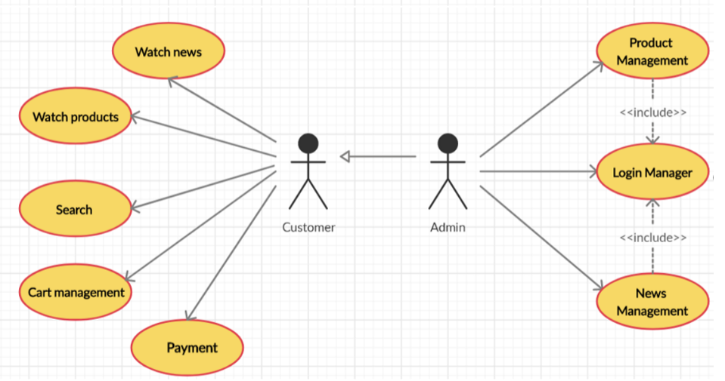

*Figure 1:Generalized usecase diagram.*

## 2.3. Decomposed usecase diagram

##### Customer usecase

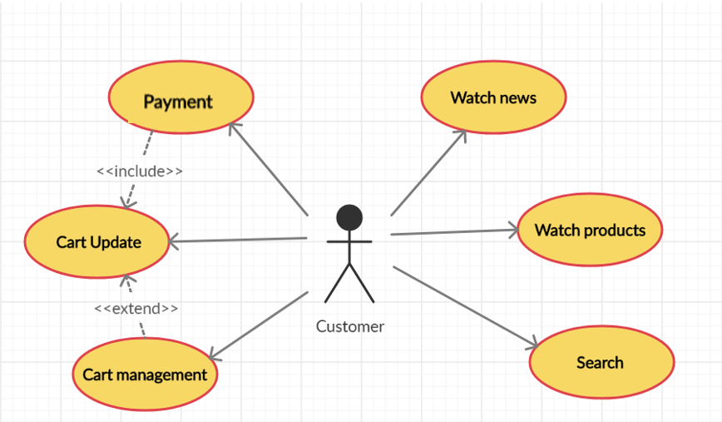

*Figure 2: Customer usecase*

##### System administration use case diagram

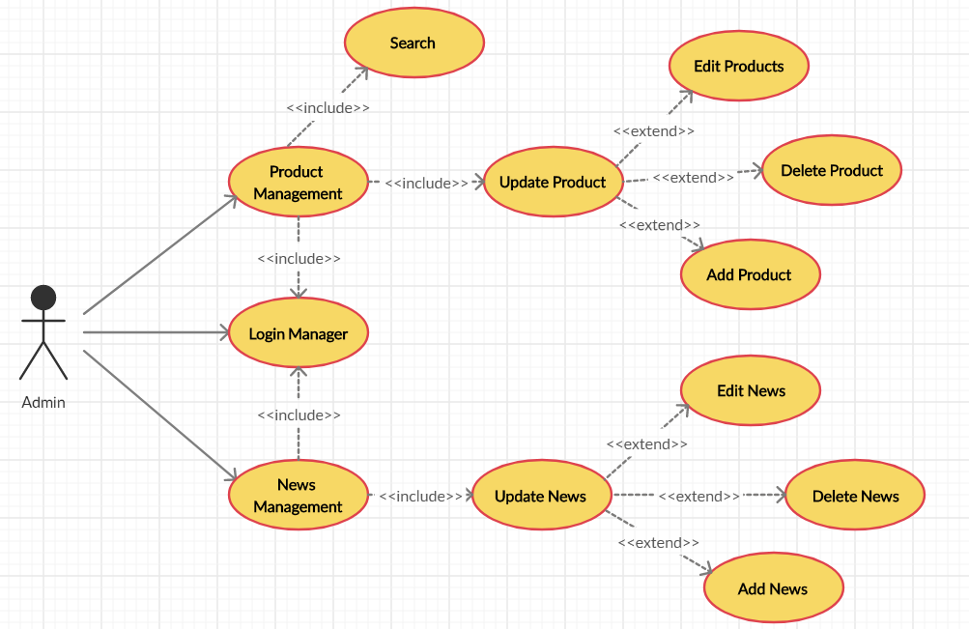

*Figure 3:System administration use case diagram*

##### Management cart usecase diagram

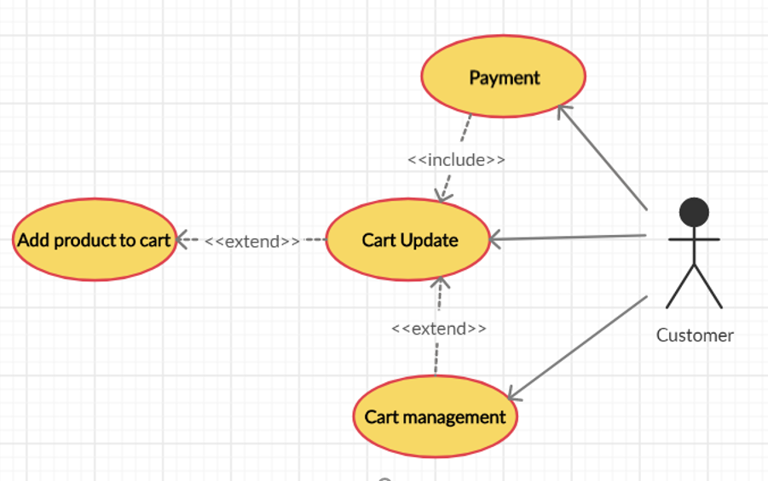

*Figure 4: Management cart usecase diagram*

##### Product management usecase diagram

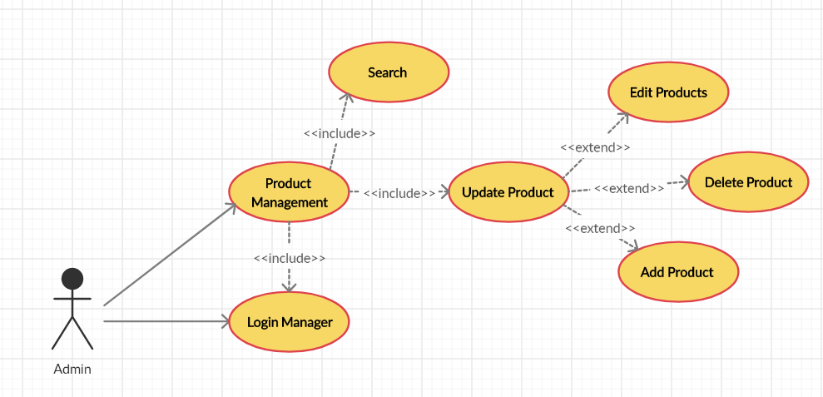

*Figure 5: Product management usecase diagram*

##### News management usecase diagram

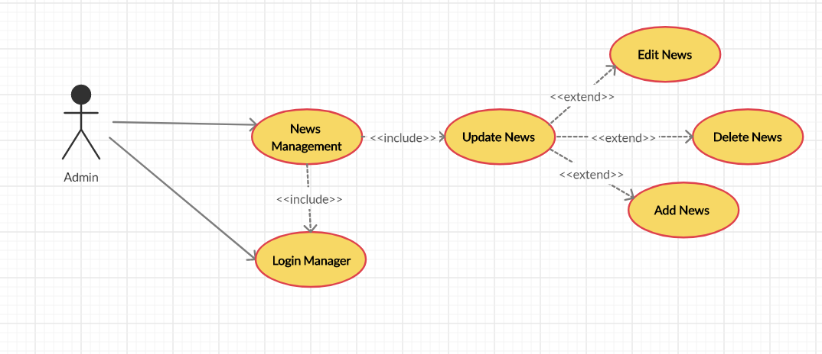

*Figure 6: News management usecase diagram*

##### Login usecase diagram

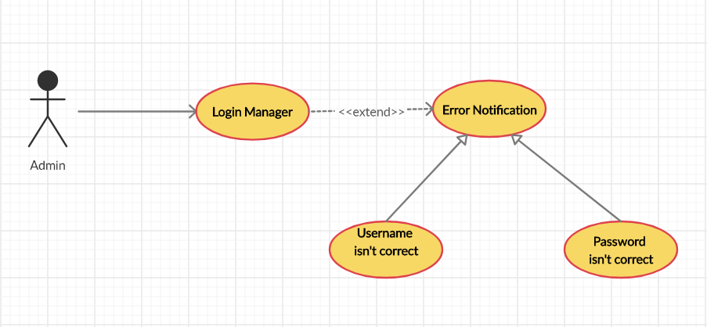

*Figure 7:Login usecase diagram*

##### Add to cart usecase diagram

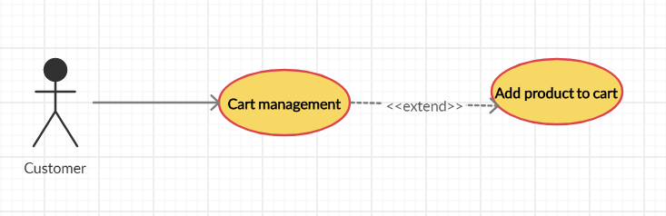

*Figure 8:Add to cart usecase diagram*

##### Payment/ Checkout usecase diagram

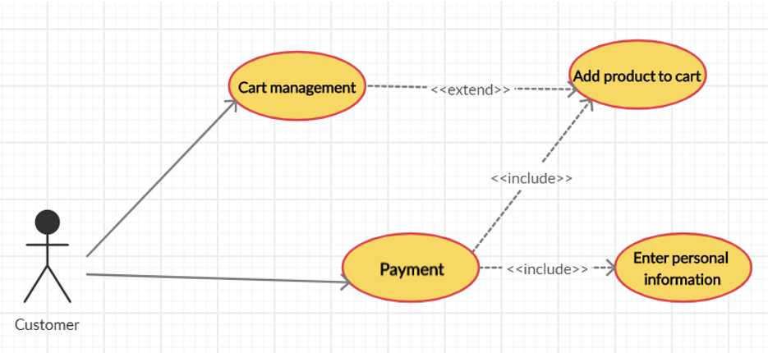

*Figure 9:Payment/ Checkout usecase diagram*

##### Cart Update usecase diagram

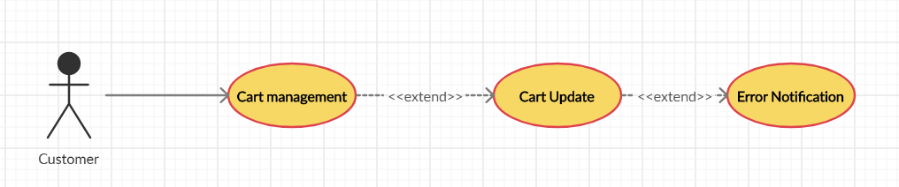

*Figure 10:Cart Update usecase diagram*

##### Delete product in Cart usecase

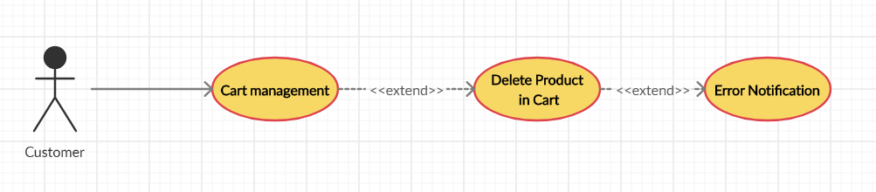

*Figure 11:Delete product in Cart usecase*

##### Add Product usecase diagram

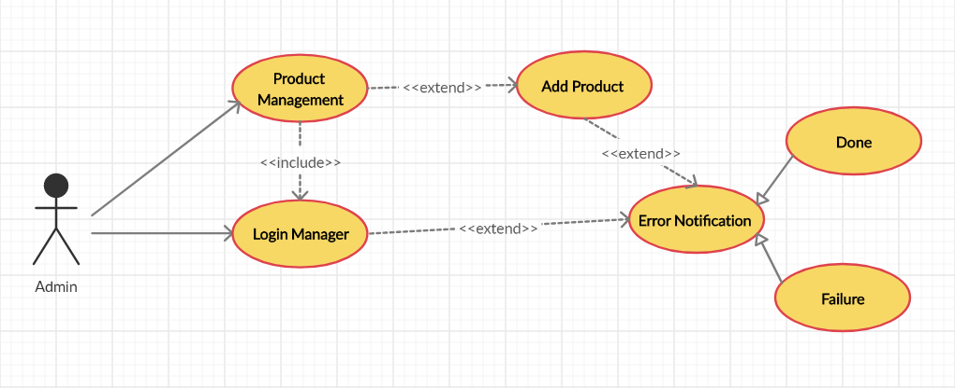

*Figure 12:Add Product usecase diagram*

##### Delete products usecase diagram

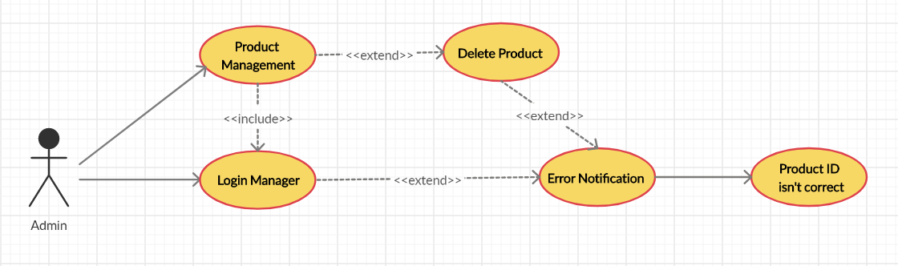

*Figure 13: Delete products usecase diagram*

## 2.4. Database design

Performing mapping from the class diagram to the relational database, the tables are as follows:

##### Customer Table

*Table 1: Customer Data*

|  |  |  |  |
| --- | --- | --- | --- |
| Name | Type | Null | Description |
| Cus_ID | Int (10) | No | Customer code |
| Cus_Name | Varchar(100) | No | Customer’s Name |
| Cus_Address | Varchar(100) | No | Customer’s Address |
| Cus_Email | Varchar(100) | No | Customer’s Email |
| Phonenumber | Int(10) | No | Customer’s Phone |
| Note | Varchar(2000) | Yes | Note about Customeer |

##### Invoice Table

*Table 2: Invoice Table*

|  |  |  |  |
| --- | --- | --- | --- |
| Name | Type | Null | Description |
| Inv_ID | Int | No | Invoice Code |
| Cus_ID | Int(10) | No | Customer’s Name |
| Dateofbuy | DateTime | No | Date of buy |
| Pro_Price | Float | No | Price for 1 product type |
| Inv_Status | Int | No | Invoice’s Status |

##### Invoce Details Table

*Table 3:Invoce Details Table*

|  |  |  |  |
| --- | --- | --- | --- |
| Name | Type | Null | Description |
| InvD_ID | Int | No | Invoice details code |
| Pro_ID | Varchar(100) | No | Product code |
| Inv_ID | Int | No | Invoice code |
| Price | Float | No | Price |
| Quantity ordered | Int | No | Quantity ordered |

##### Product Table

*Table 4: Product Table*

|  |  |  |  |
| --- | --- | --- | --- |
| Name | Type | Null | Description |
| Pro_ID | Varchar(100) | No | Product code |
| Pro_Name | Varchar(100) | No | Product’s Name |
| Content | Varchar(1000) | No | Content for product |
| Pro_Image |  | No | Image |
| Pro_Price | Float | No | Price for 1 product type |
| Quantity | Int(10) | No | Quantity |
| View | Int | No | Number of view |

##### User Table

*Table 5:User Table*

|  |  |  |  |
| --- | --- | --- | --- |
| Name | Type | Null | Description |
| User_ID | Int(10) | No | User code |
| UserName | Varchar(100) | No | UserName |
| PassWord | Varchar(100) | No | PassWord |
| User_Adress | Varchar(100) | No | Address of user |
| User_Email | Varchar(100) | No | Email of user |
| PhoneNumber | Int (10) | No | PhoneNumber |

##### Menu Table

*Table 6:Menu Table*

|  |  |  |  |
| --- | --- | --- | --- |
| Name | Type | Null | Description |
| Menu_ID | Int | No | Menu Code |
| Menu_Name | Varchar(100) | No | Menu’s Name |
| Level | Int | No | Level |
| Menu_Search | Int | No | Menu_Search |

##### IP Table

*Table 7:IP Table*

|  |  |  |  |
| --- | --- | --- | --- |
| Name | Type | Null | Description |
| IP_ID | Int | No | IP code to access |
| Pro_ID | Varchar(100) | No | Product Code |
| IP_Name | Varchar(100) | No | Name’s IP that customer accessed |

##### Customer Database Table

*Table 8:Customer Database Table*

|  |  |  |  |
| --- | --- | --- | --- |
| Name | Type | Null | Description |
| ID | Int | No | Mã lưu vết |
| IDSanPham | Int | No | Mã sản phẩm |
| IDKhachHang | Int | No | Mã khách hàng |

* Some datasheets for interface modules

##### News Table(Contains articles for introductions, buying guides)

*Table 9:News Table*

|  |  |  |  |
| --- | --- | --- | --- |
| Name | Type | Null | Description |
| New_ID | Int | No | New code |
| Ad_ID | Int(10) | No | Admin code |
| Title | Varchar(200) | No | Title |
| Image |  | No | Image |
| Content | Varchar(2000) | Yes | Acticles |

##### Admin Table

*Table 10:Admin Table*

|  |  |  |  |
| --- | --- | --- | --- |
| Name | Type | Null | Description |
| Ad_ID | Int(10) | No | Admin code |
| Admin name | Varchar(100) | No | Username |
| Admin_password | Varchar(100) | No | PassWord |

## 2.5. Relational model

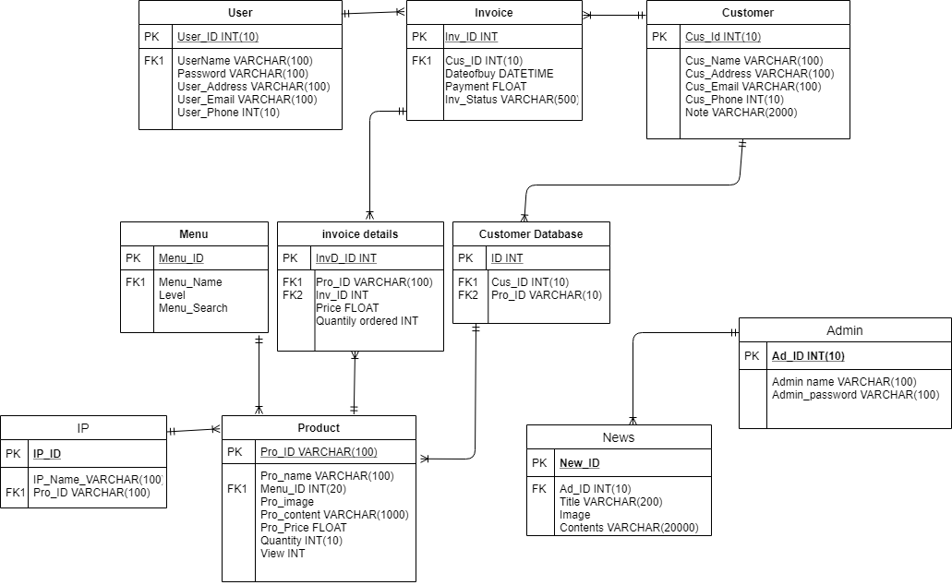

## 2.6. Sequence Model

##### Sequence diagram added to cart

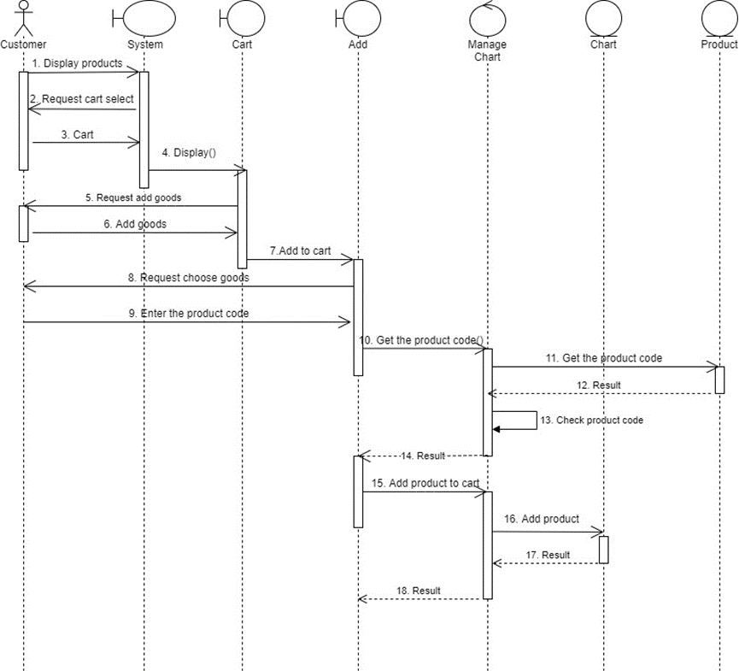

##### Sequence diagram of deletion order in cart

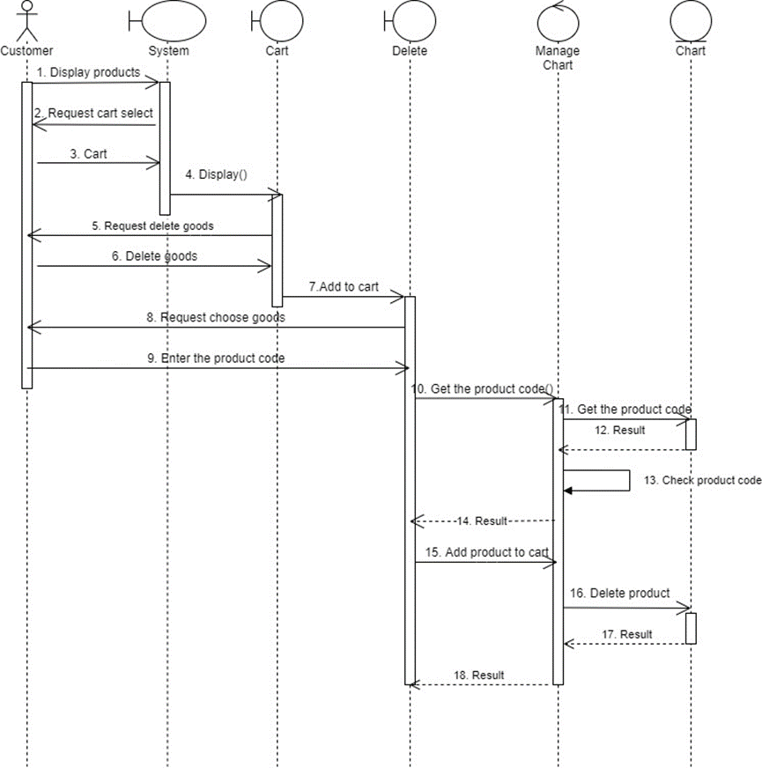

Product repair sequence diagram 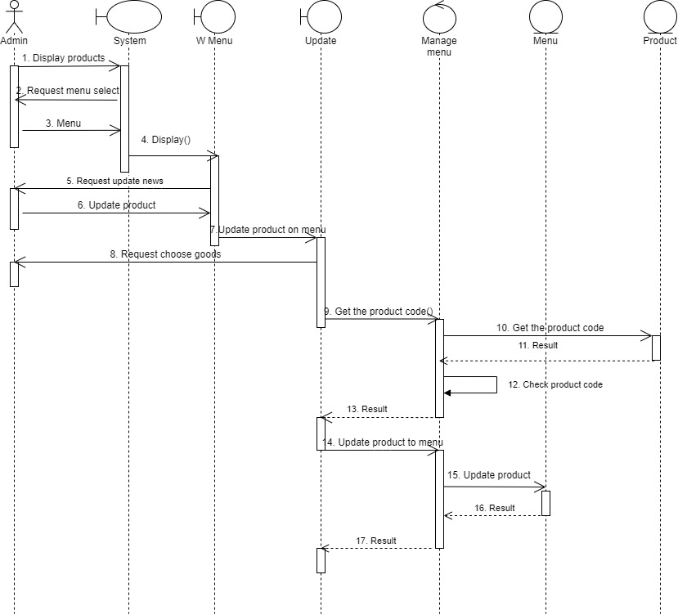

Sequence diagram for product use case delete 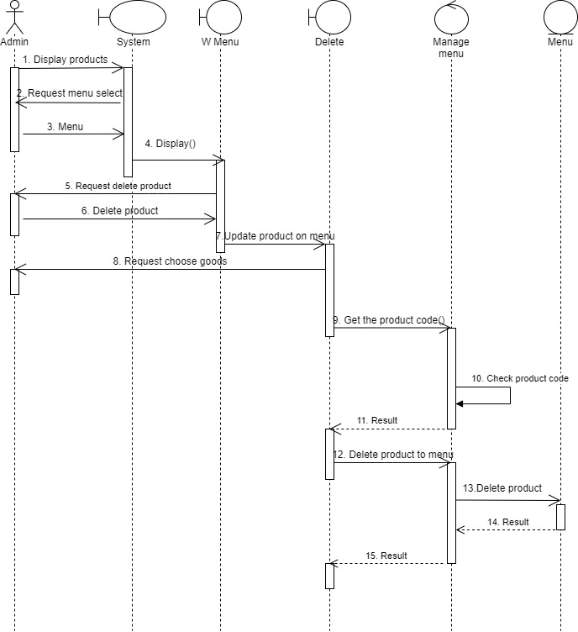

Sequence diagram for adding news 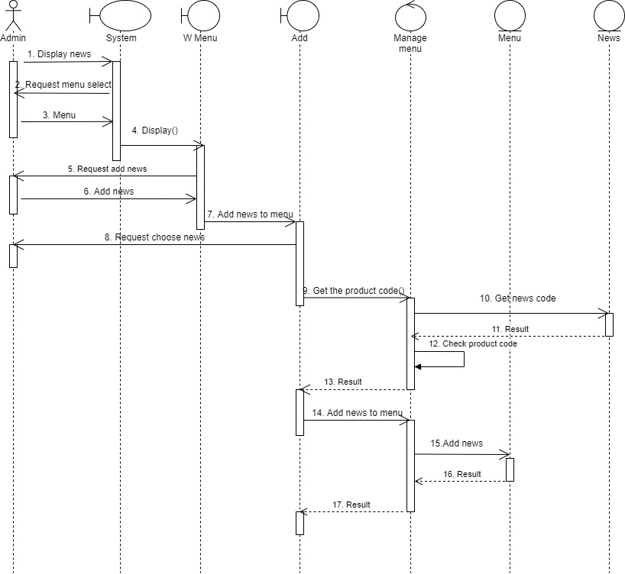

##### Sequence diagram for updating news

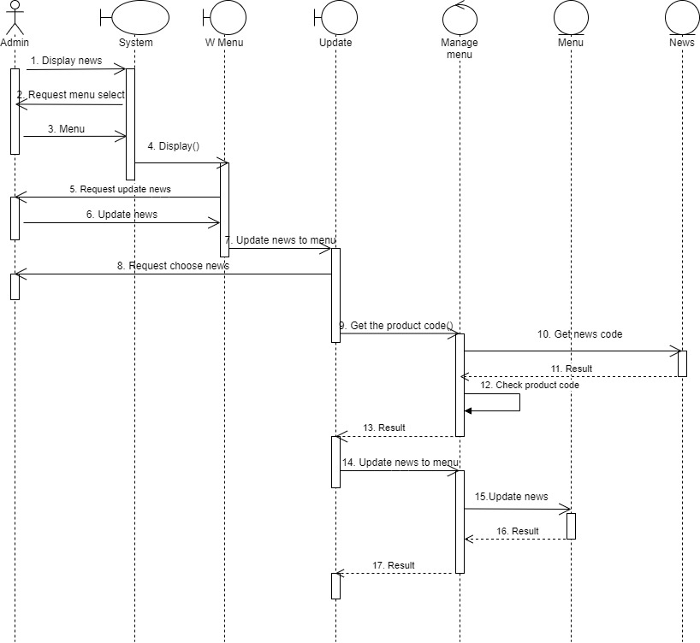

##### Sequence diagram for deleting news

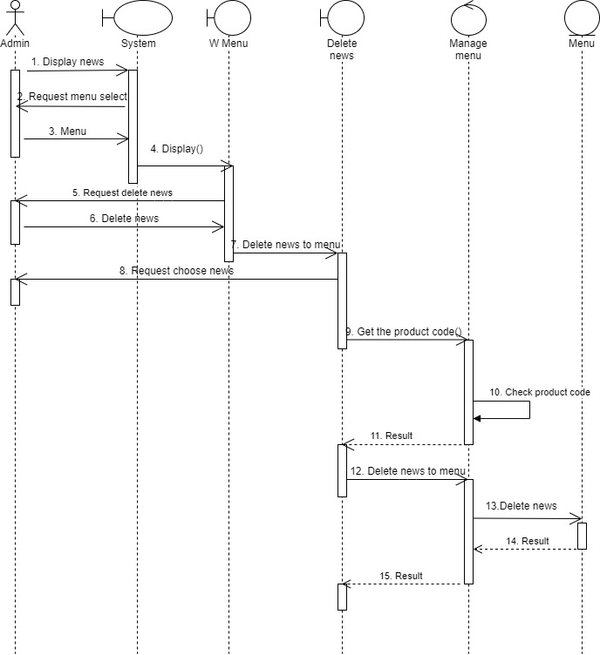

# Chapter 3: Achievements and development directions

## 3.1. Results interface

Webstie Management of clothing sales has fully served the functions of small and medium-sized hotels. Overcoming the disadvantages of traditional management methods such as:

• Management by phone book, employees have to take a lot of records thus leading to confusion.

• When taking inventory, must check each product by product type. During recording, inventory may be misleading.

• Can only be sold to customers on a limited scale and must go to the store.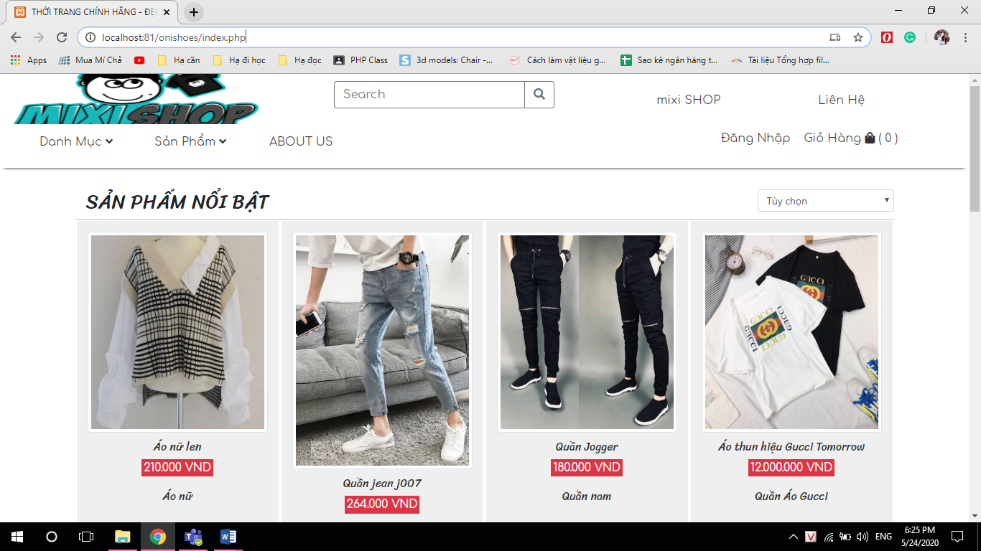

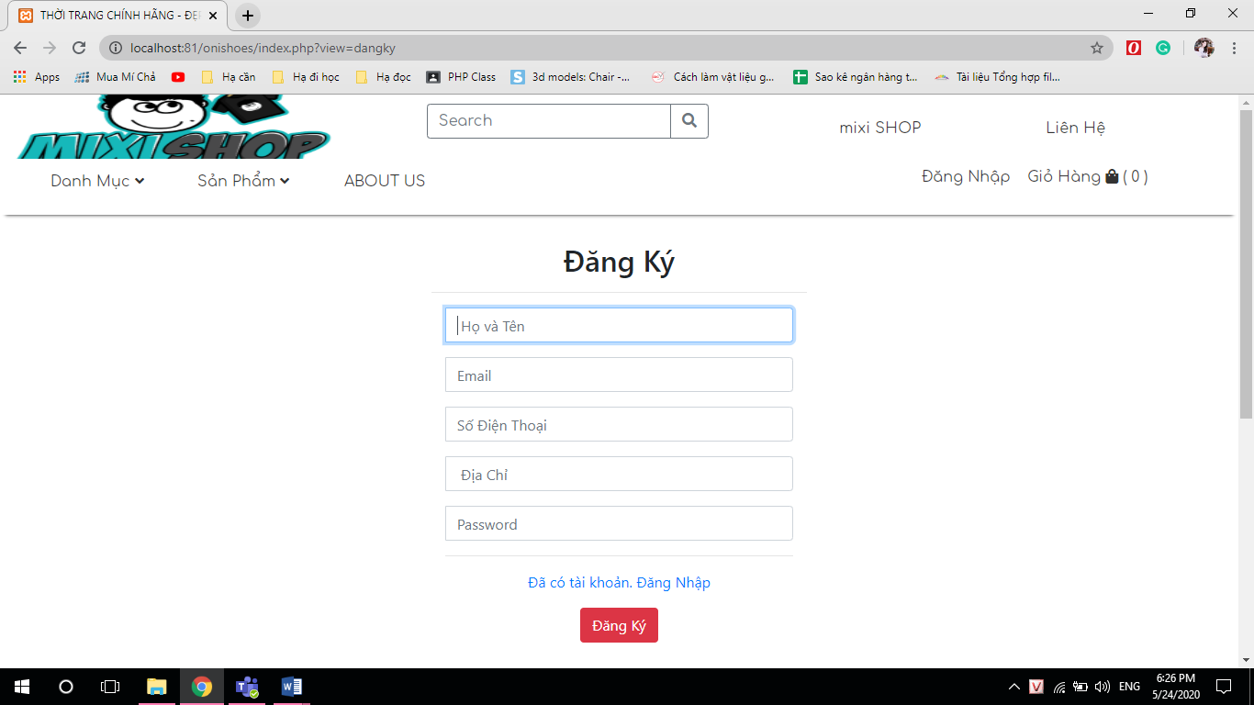

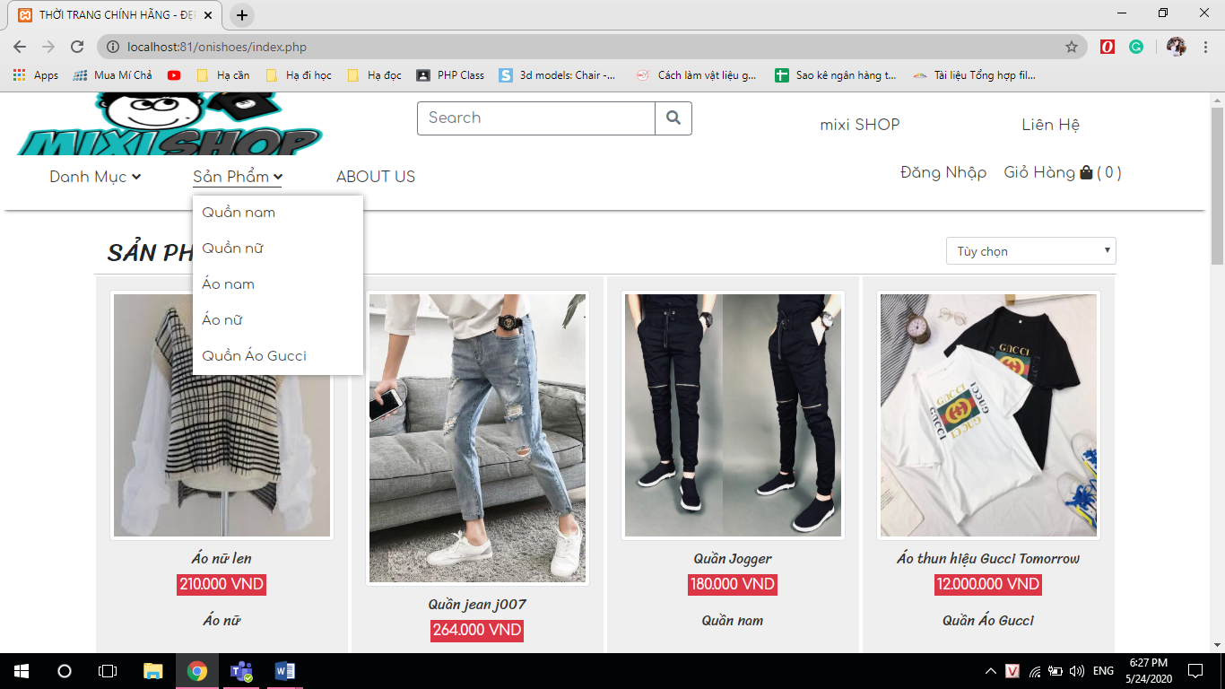

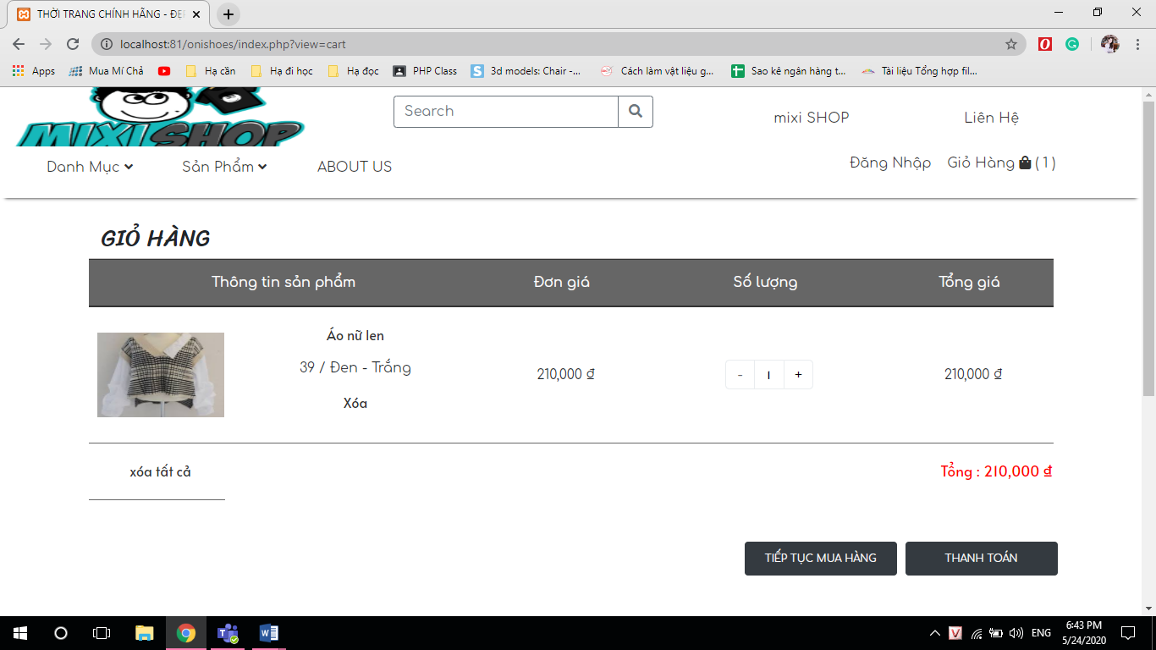

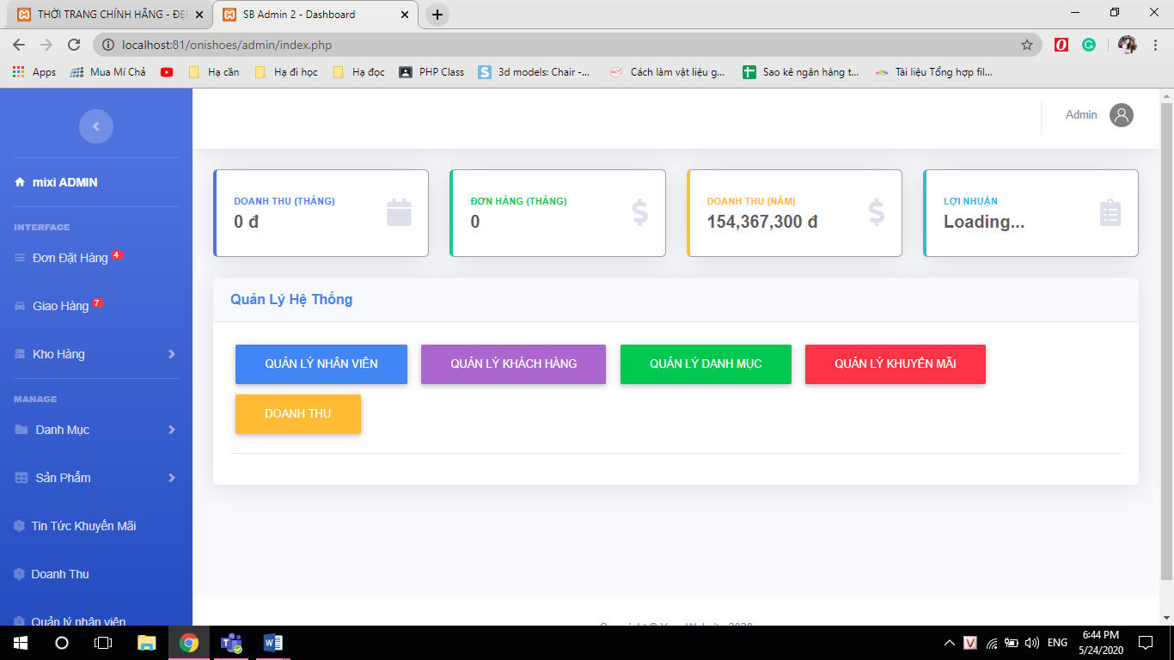

## 3.2. Development

With their own efforts, the project team tried to complete the topic request. Due to the limited time and capacity, the group's website is only going into selling products.

The topic group aims to develop a website into a professional sales website. Provide a full range of products currently on the market with reasonable and affordable prices. Comes with sales are the most prestigious and quality services to serve customers.

# REFERENCES

[1]. Document: Phạm Hữu Khang, Quản trị My SQL, NXB Thống kê, 2008.

[2]. Document: Mai Minh Tuấn - Đỗ Hữu Phú, Giáo trình Cơ sở dữ liệu, NXB Giáo dục, 2011.

[3]. Document: Dương Quang Thiện, C# và php Framewoek, NXB Tổng hợp TP HCM.

[4]. Document: Phạm Trung Kiên, Kỹ thuật lập trình web với Ajax, NXB Hồng Đức, 2007.

[5]. Document: Rebecca M. Riordan, Microsoft php Step by Step, O’Reilly Media, 2005.

[6]. Document: Jesse Liberty, Programming C# php, O’Reilly Media.

[7]. Website: https://www.aspphp/mvc/

[8]. Website: https://www.w3schools.com/

[9]. Website: https://www.mkyong.com/

[10]. Website: https://www.google.com.vn/

[11]. Website: https://stackoverflow.com/

[12]. Website: https://creately.com/